Reasonable Design:  
NY Times: American Incomes are Losing Their Edge, Except at the Top

Tasks: This visualization aims to compare American incomes with those of Canada and other countries in Europe. It also shows the changes in income for these countries from the 80’s to the present and is arguing that America is falling behind from when the middle class was the richest in the world.

Visual Mapping: The visualization maps temporal data and income percentile data to a double x-axis. Actual income data is inflation adjusted and mapped to lines for each country and for each percentile according to the income amount on the y-axis.

Justification: I think this design is good because it provides a solid overview and the ability to filter and get more detail in the visualization. The overview highlights the United States with a different color so that we can focus on how U.S. incomes stack up to other countries, and showing every 5th percentile shows that U.S. income is only far above the rest at higher incomes. The temporal data helps show how this was not always the case, and transparency keeps the other countries’ lines from becoming clutter. By checking the remove smoothing box, the lines become more jagged and show year-to-year changes in the time period. We can also filter for 1-to-1 comparisons with the U.S. by hovering over the lines.

Bad Design:

Washington Post: Leaving downtown at rush hour in America’s largest cities

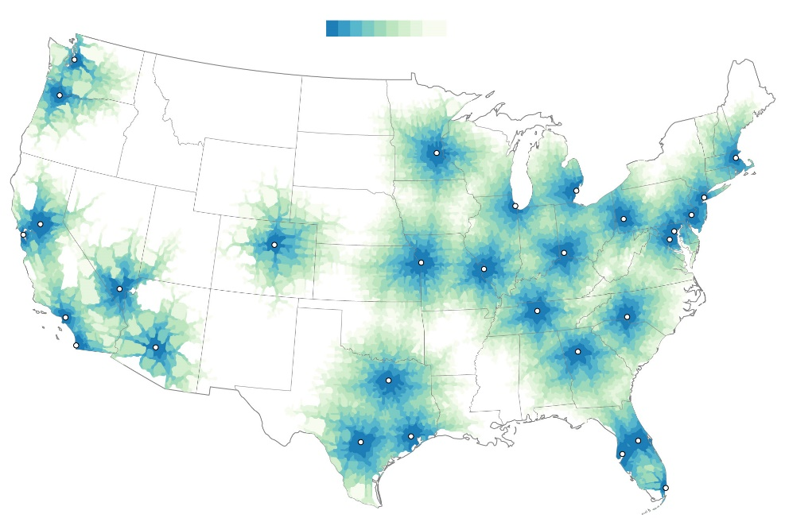

Tasks: The visualization aims to show possible distance traveled in a time period from American cities. It can be used to compare rush hour between cities based on how far from downtown you can travel.

Visual Mapping: The visualization uses a map since it encodes geographical data. Color is used to encode distance traveled per time unit between 1 hour and 5 hours. Areas within each distance are colored.

Justification: If you take an individual city on this map, you can get a general idea of how far you can travel from downtown in 5 hours. However, certain cities overlap in their color so it becomes less clear for cities like D.C. and Philadelphia. This is only an overview as well, so we don’t know the actual distance indicated on the map. Although we can try and compare distances, we would have to look at area colored which is hard for us to do, and is really only possible for the 1 hour zones since they are continuous and centered.

2. UN Data Design

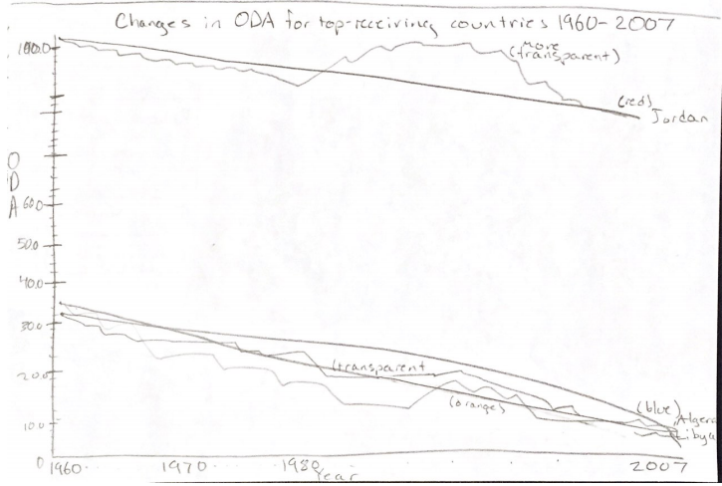

Since this design is for a static image, I chose to highlight certain countries instead of all the countries in the dataset. For this design, I am trying to answer whether or not countries that received a large amount of aid in 1960 were better off in 2007. This helps to answer if the ODA is effective. So this design would use the countries that received the most aid in 1960 (<10) and create a line graph for each country’s data.

Years are represented on the x-axis to encode temporal data, and ODA is on the y-axis. Each year should have a mark on the axis. ODA should scale from 0 to slightly above the maximum amount for clarity in the scale and have reasonable subdivision for the detailed view. First, the data points for 1960 and 2007 will be drawn and connected by a solid line. Each country’s line will be a different color to help distinguish them and reduce clutter. The country’s name will be at the end of its line instead of having a legend. This provides an overview of the change data.

For some detail, each country will have a second, somewhat transparent line connecting the data points for each year that is the same color as the first line. The goal of these lines is to provide the detail view if the viewer wishes to track changes between 1960 and 2007, but they will be able to quickly see whether countries were receiving less aid in 2007 compared to 1960.

Hopefully this chart will answer whether ODA is effective for countries, but will also show fluctuations in ODA over time well. Since the image will be showing changes for countries that needed assistance in 1960, it ignores the situation of countries that may have needed little assistance in 1960, but got significantly worse by 2007.